Volunteer Information Form
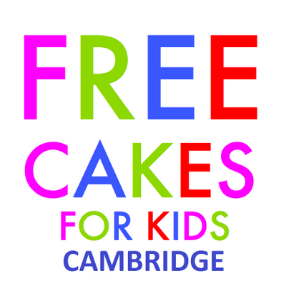
BEDFORD

Your Details
Name: ___________________________________________________
Address: ___________________________________________________
Phone number: ___________________________________________________
Email: ___________________________________________________

Employment (please circle):
Full-time / Part-time / Student / Unemployed / Retired / Other
We usually ask volunteers to deliver their own cakes – please confirm if you’re able to do so: Yes / No
About You
Please tell us briefly why you’d like to get involved with Free Cakes for Kids:

Please tell us a bit about your baking experience (although you don’t need to be an expert baker to help!):

If you have any recommendations for organisations that we could contact for baking referrals, please let us know:

Food Safety
Please confirm that you’re happy to sign our food safety policy: Yes / No
Our volunteers aren’t expected to undertake food safety training, but it’d be great to know if you have any safety/hygiene certificates etc. Please list any details below:

Other Baking Opportunities
Free Cakes for Kids Bedford sometimes bakes for non-child-related groups or organisations, as well as for community or fundraising events – or even just in order to meet up with our volunteers!
There’s absolutely no pressure to get involved with these, but please circle below (or add a comment) for the following options:
Would you like to make birthday cakes for people other than children?
(e.g. referrals via homeless shelters or elderly care homes) Yes / No

Would you be happy to bake requests other than birthday cakes?
(e.g. baking for community events or fundraising activities) Yes / No

Would you be interested in helping out with events?
(e.g. running cake stalls or assisting with kids’ baking workshops) Yes / No

Would you enjoy attending group meetings for volunteers?
(e.g. skill-swap meet ups or workshops on cake-decorating skills) Yes / No

Signed: _____________________________
Date: _____________________________

