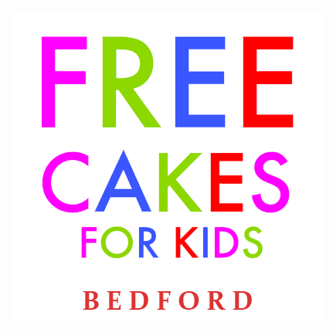
Becoming a Volunteer Baker for
Free Cakes for Kids

Free Cakes for Kids are looking for volunteer bakers who are willing to make a birthday cake for a child in their local area. The idea behind Free Cakes for Kids is simple; we match enthusiastic bakers with families who find it difficult to provide a birthday cake for their child.
What do I have to do?
Once you have applied to become a volunteer baker, we can add you to our network of bakers. When a referral comes in, we email our team of volunteer bakers with details of the referral asking someone to volunteer to bake a cake for the child in question.
Do I have to commit to making a certain number of cakes?
No. You might make one cake a year, you might make one a month; it really is up to you. Becoming a volunteer baker is flexible; you can fit it around your commitments and bake when you have the time.
Do I have to be an expert baker?
No. The aim of Free Cakes for Kids is to help families who find it difficult to provide a (homemade) birthday cake for their child. For many of these children receiving a homemade birthday cake, perhaps with their name on it or in the shape of something they really like, will make a real difference whatever the cake looks like and there are no expectations that cakes look professional or ‘shop bought’.
Who covers the cost of ingredients?
Volunteer bakers are to be willing to cover the costs of their cakes themselves. However, if we have funds in our petty cash box, we will offer we will offer the baker £5 towards the cost of baking a cake for us.
How will the cake be delivered?
This will vary with each different referral. In most cases volunteer bakers should expect to deliver the cake to a location in and around their local area.
If you would like to apply to become a volunteer baker with Free Cakes for Kids, please
Email freecakesbedford@gmail.com or call Sally 07927 337636
Please return completed forms to: -
Free Cakes for Kids, 42 Riverside View, Milton Ernest, Bedfordshire MK44 1SG

